# Hotel

# Use-Case: Check Out

1. Brief Description

When a customer

Wants to leave the hotel they checkout

So that they can pay the final bill

1. Actors

Customer

1. Pre-Conditions
   1. The main menu is displayed
2. Normal Flow

The use case begins when customer selects check out option on the main menu.

|  |  |  |
| --- | --- | --- |
| Actor | System | Pass/Fail |
|  | 1. Prompt to enter room number | PASS |
| 1. Enter room number | 1. Display final invoice | PASS |
|  | 1. Prompt to accept charges | PASS |
| 1. Accept charges | 1. Prompt to enter credit card type | PASS |
| 1. Enter credit card type | 1. Prompt for credit card number | PASS |
| 1. Enter credit card number | 1. Prompt for ccv | PASS |
| 1. Enter ccv | 1. Display checkout debit message | PASS |
|  | 1. Prompt to hit Enter | PASS |
| 1. Press Enter | 1. Display checkout complete message | PASS |
|  | 1. Display main menu | PASS |

The use case ends.

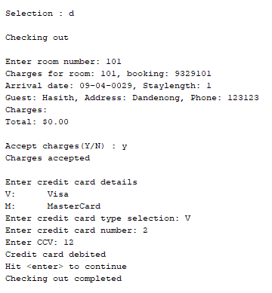

1. Alternate Flows
   1. Room Number Not Found

If at step 3, of the normal flow the booking for the room is not found, then

|  |  |  |
| --- | --- | --- |
| Actor | System | Pass/Fail |
|  | The system displays a no active booking found message | PASS |

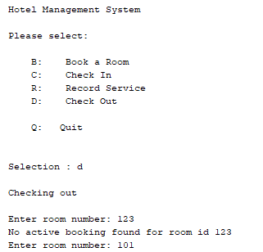The normal flow is resumed at step 1.

* 1. Charges Not Accepted

If at step 5, of the normal flow the charges are not accepted, then

|  |  |  |
| --- | --- | --- |
| Actor | System | Pass/Fail |
|  | The system displays a charges not accepted message | PASS |
|  | The system displays a checkout cancelled message | PASS |

The use case ends.

* 1. User Cancels

If at steps 2, or 7 of the normal flow the user provides null input then

|  |  |  |
| --- | --- | --- |
| Actor | System | Pass/Fail |
|  | The system displays a cancelled message | PASS |

The use case ends.

* 1. User resets during cost entry

If at step 9, or 11, of the normal flow the user provides null input then

The normal flow is rejoined at Step 6

1. Key Scenarios
   1. Successful check out
   2. No booking found, the room re-entered and successful checkout
   3. Charges not accepted
   4. Credit not authorized, new card input, successful checkout
   5. Credit not authorized, checkout cancelled
2. Post-conditions
   1. Normal flow and other flows where checkout is successful.

The booking status is updated to CHECKED_OUT

The room status is updated to READY

The credit card authorizer was asked to authorize the amount on the invoice

The booking can no longer be found as an active booking by roomId

* 1. All other unsuccessful scenarios

No change to anything